**Docker**

Docker is an open platform for developing, shipping, and running applications. Docker enables you to separate your applications from your infrastructure so you can deliver software quickly. With Docker, you can manage your infrastructure in the same ways you manage your applications. By taking advantage of Docker’s methodologies for shipping, testing, and deploying code quickly, you can significantly reduce the delay between writing code and running it in production.

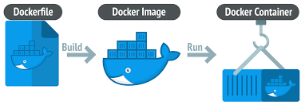

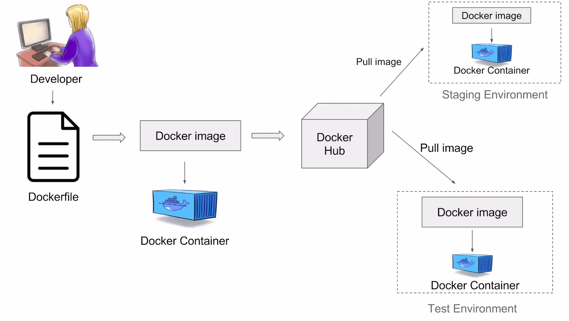

**Workflow:**

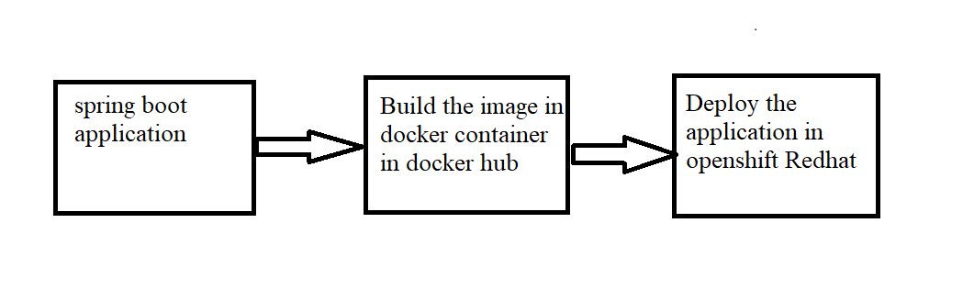

**Step1:** A simple spring boot application

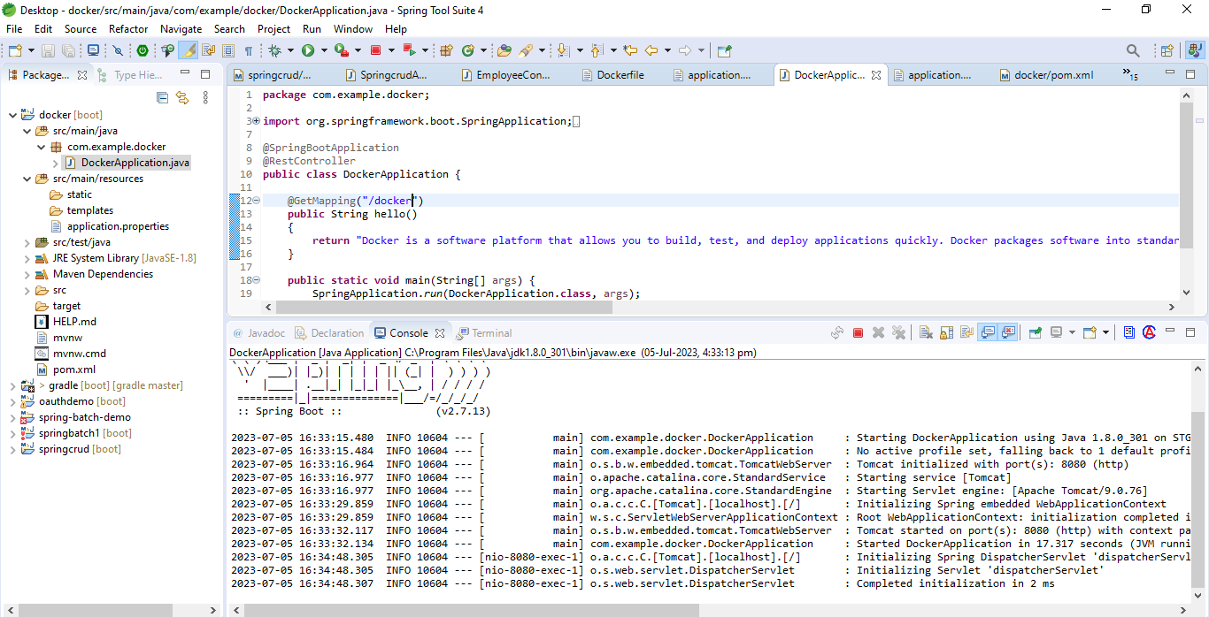

**Step2:** It was working fine in the local

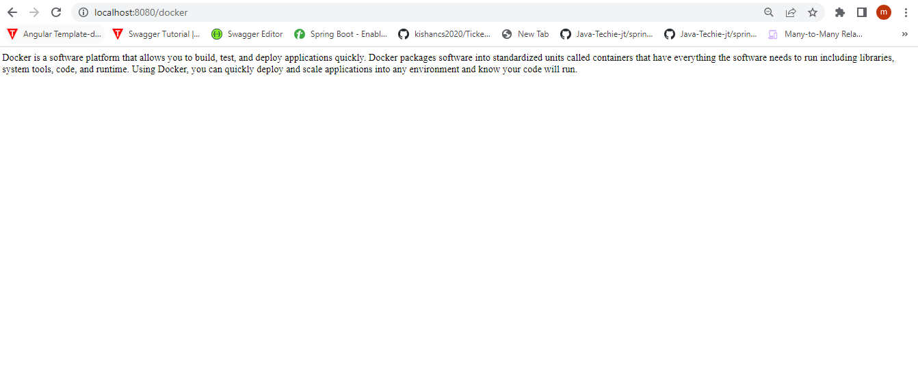

Create one Dockerfile for pushing the application from local to docker desktop

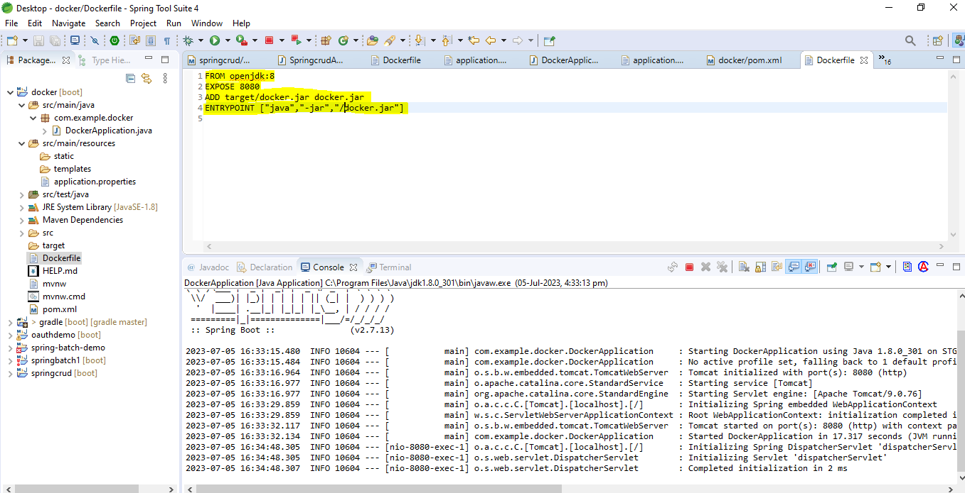

**Step3:** For seeing an image in docker, command is docker images

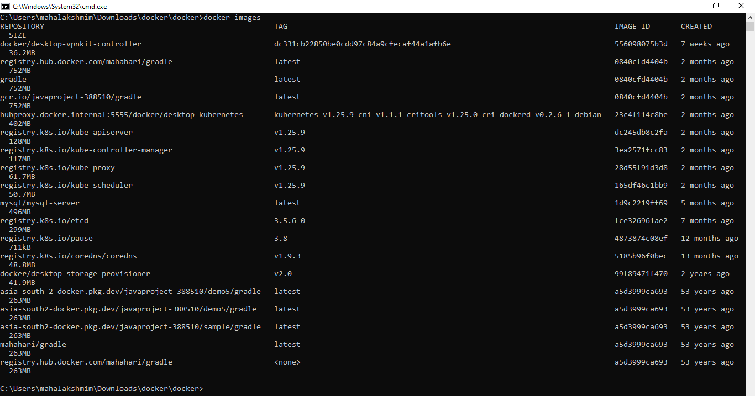

**Step4:** For building an image this command is required docker build –t <jar name>.jar .

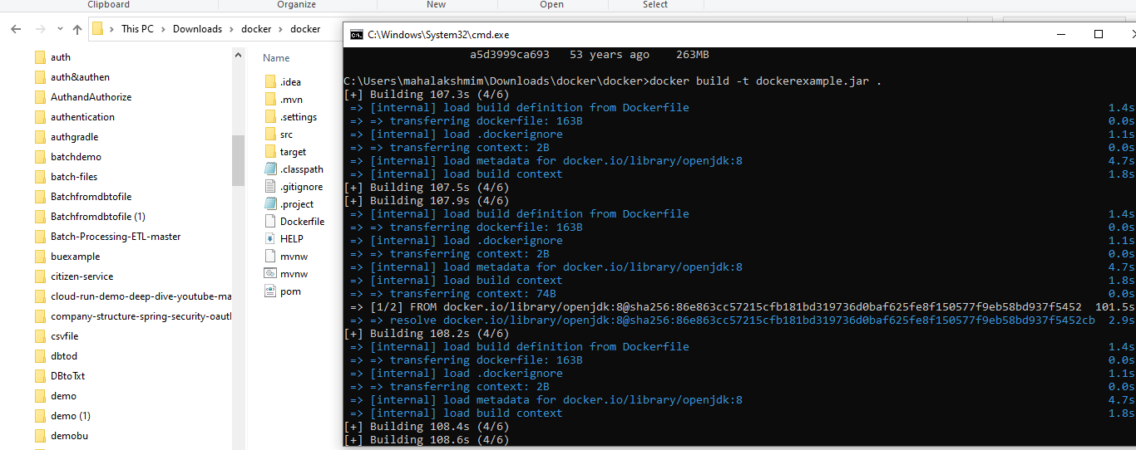

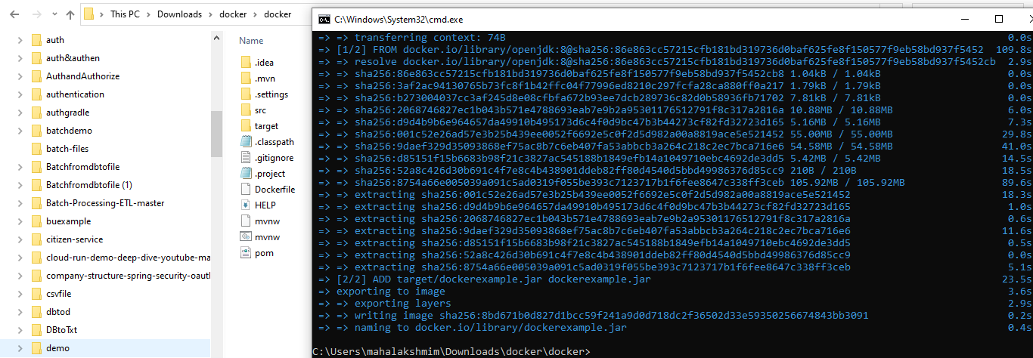

For check the image is build successful we can check it by using the command docker images

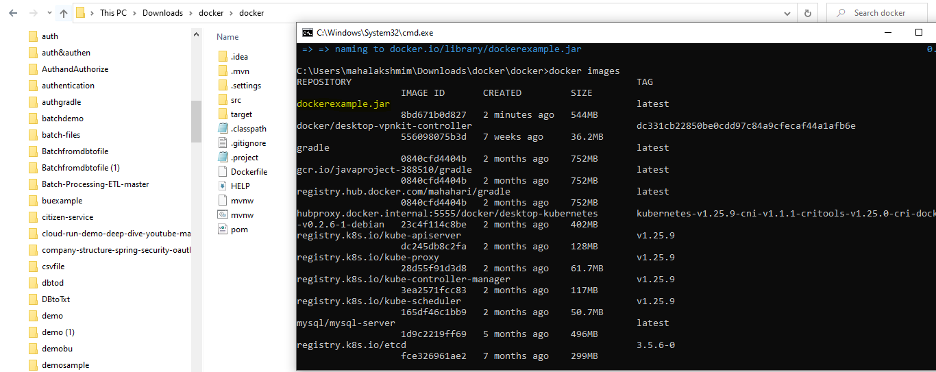

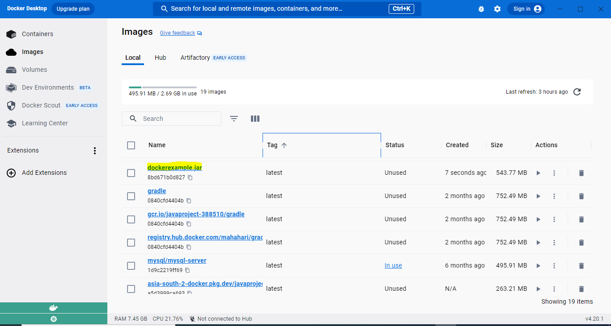

**Step5:** For running the docker image in the docker container

docker run –p 9090:8080 <jar_file_name>.jar

9090: is the docker port that the image is running in the container

8080: is the application that was running locally

Eg : **docker run -p 9090:8080 dockerexample.jar**

The application was running successfully in docker container

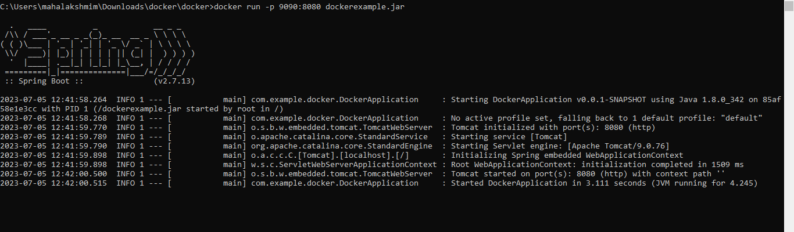

**http://localhost:9090/docker**

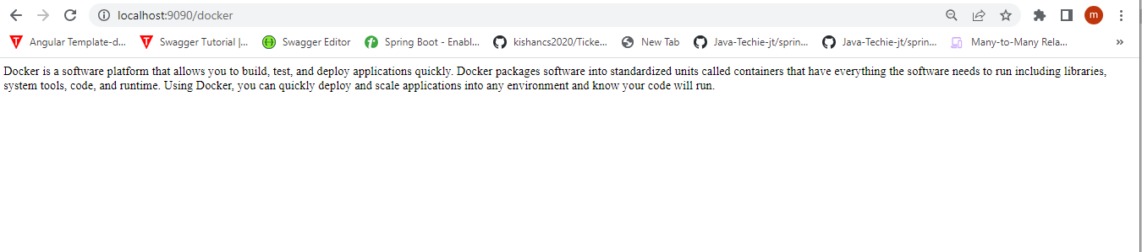

I can check this one using my IP address replace the localhost in my url ,I can replace it with the IP address of my system

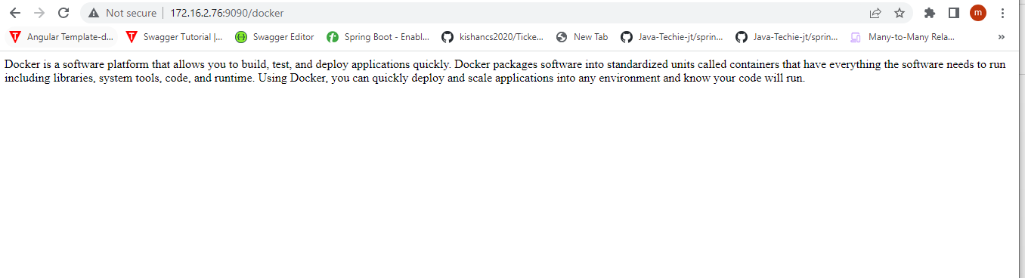

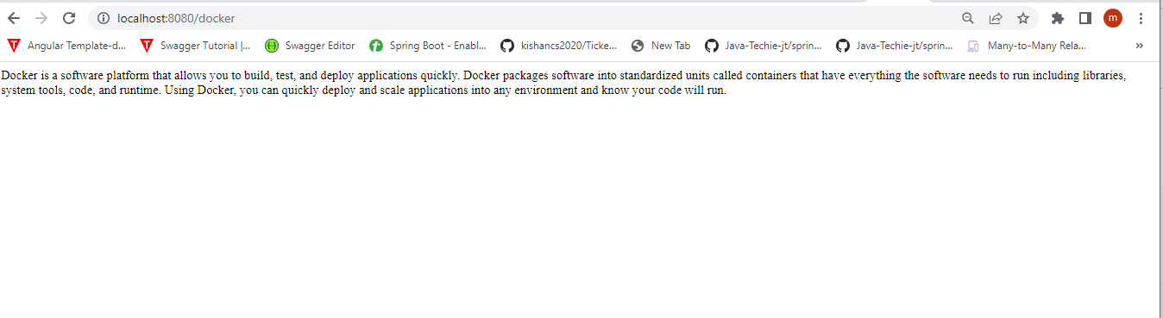

**Step6: How to push this image into DockerHub**

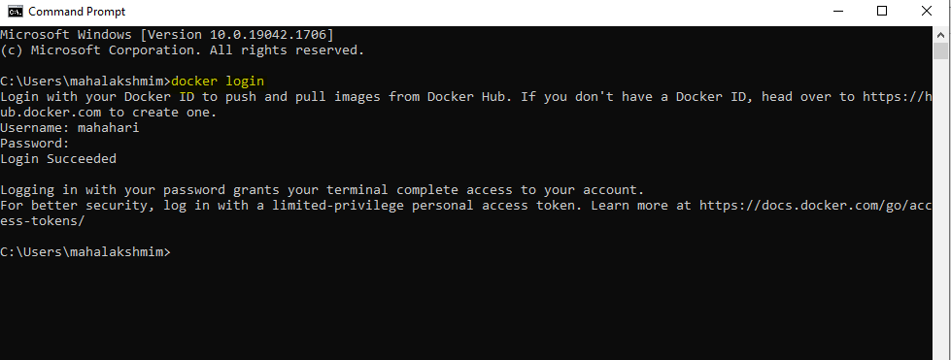

docker tag <image-name> <docker-hub-username>/<repository-name>:<tag>

eg: docker tag dockerexample mahahari/example:latest

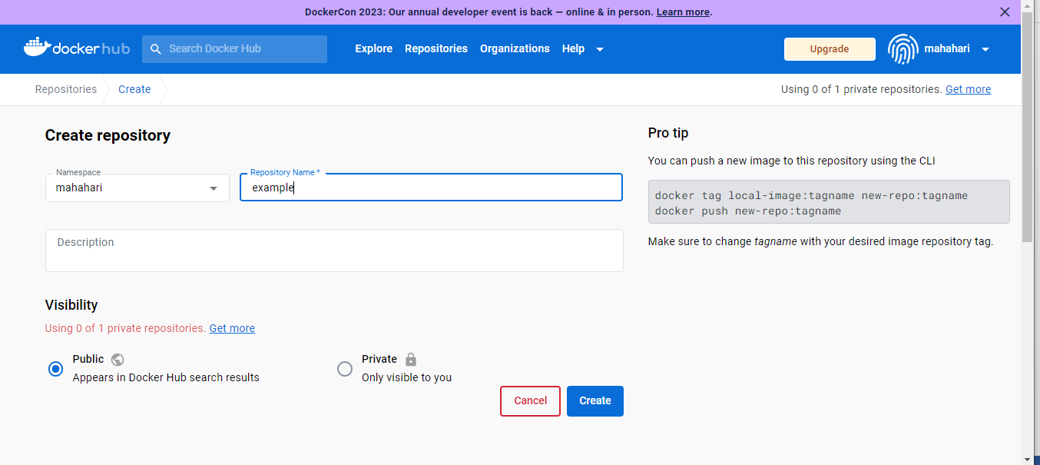

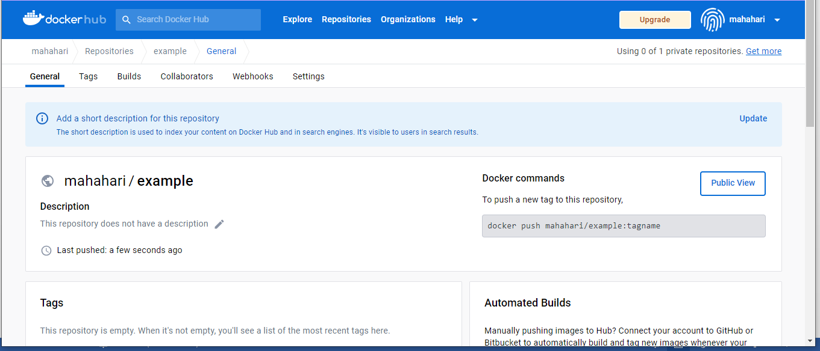



**Step7:Pushing the image from Docker desktop to Docker hub**

docker push <docker-hub-username>/<repository-name>:<tag>

eg: docker push mahahari/example:latest

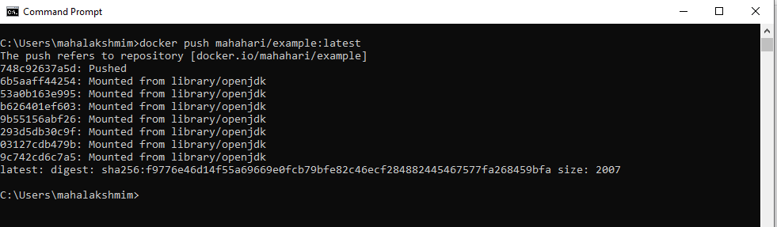

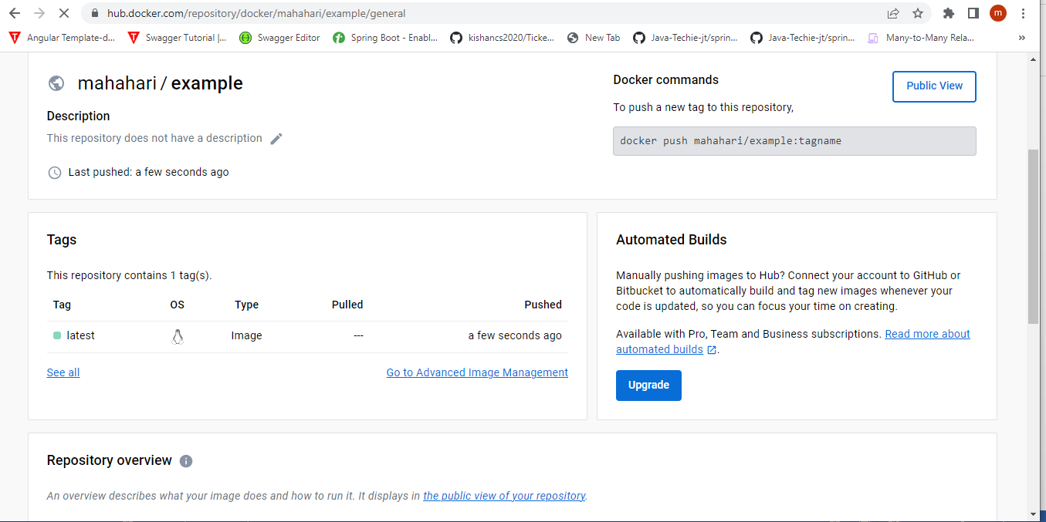

**Step8: Deploying this image from Docker hub container to openshift Redhat Dedicated platform**

First need to create a account in openshift redhat dedicated platform then ,need to choose

Add->ContainerImages

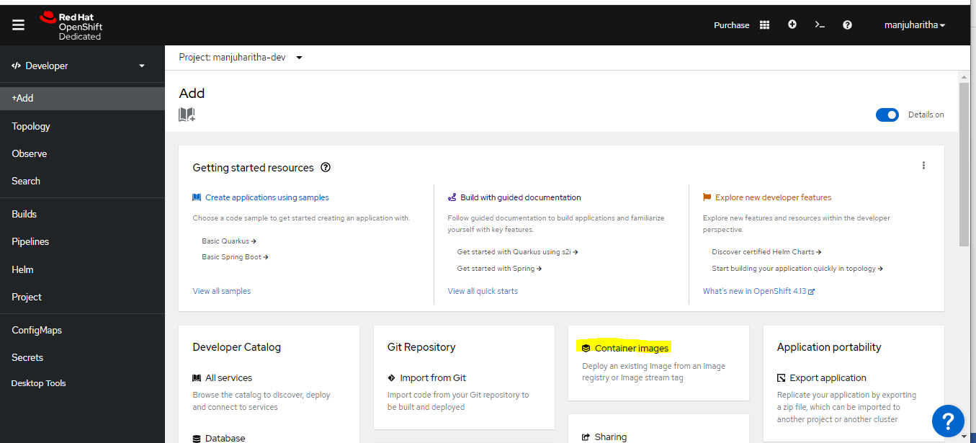

Here I need to specify the container image tag in my docker hub

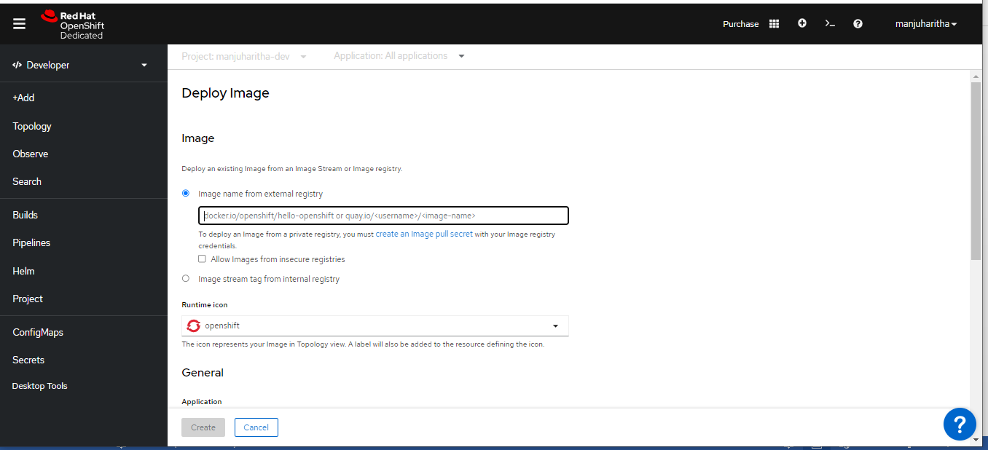

This is the TAG name I need to provide in redhat openshift dedicated platform

